Chapter 13, Problem 52.

For the circuit in Fig. 13.116, determine the turns ratio n that will cause maximum average power transfer to the load. Calculate that maximum average power.

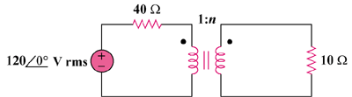

Figure 13.116
For Prob. 13.52.

